CHAPTER 6: The mysterious universe

Worksheet 6.4

The expanding universe
Answers

The Doppler effect
1. Figure A shows a light emitting object moving to the right. The light emitted is detected by two stationary observers (O₁ and O₂). Figure B shows absorption spectra of a light emitting object. The dark lines represent colours of light that have been absorbed by different elements in the star.
A |  | B
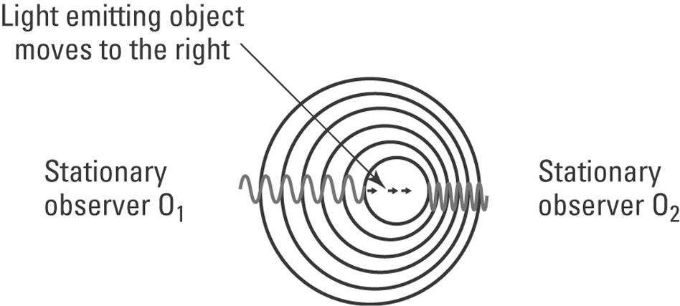 |  | 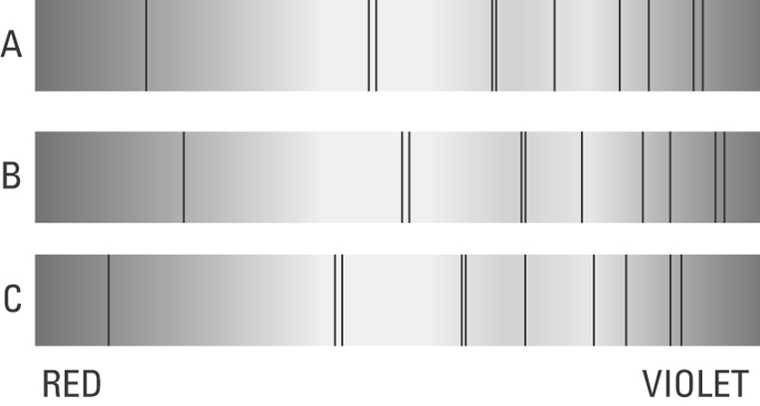
(a) Explain the Doppler effect using figure A.
Observer 1 sees the light source moving away from them. The light waves emitted from this source spreads out, increasing the wavelength. This is seen as a red shift in the light. Observer 2 sees the light source coming towards them and the light waves bunch up, decreasing the wavelength. This is seen as a blue shift in the light.

(b) The dark lines in the spectra in figure B show red and blue spectral shifting. One spectrum is of a light source that is stationary relative to the observer. Identify the spectrum (X, Y or Z) in which the light emitting source is moving:
C
(i) away from the observer
B
(ii) towards the observer.
CHAPTER 6: The mysterious universe

Worksheet 6.4

Page 2

Hubble’s expanding universe
2. The following graph shows a plot of the velocities of a number of galaxies moving away from our galaxy versus their distance from the Earth.

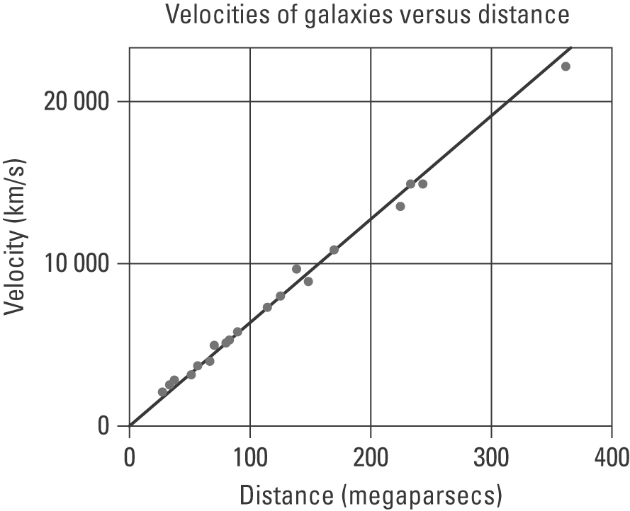
(a) Describe the trend demonstrated by the graph.
The greater the distance a galaxy is from the Earth, the greater its velocity as it moves away from Earth, i.e. the further away the galaxy the faster it is moving.

(b) Explain why these galaxies are moving away from our own.
The universe has been expanding since the big bang and continues to expand today. Therefore, these galaxies, including our own, are moving away from each other.

